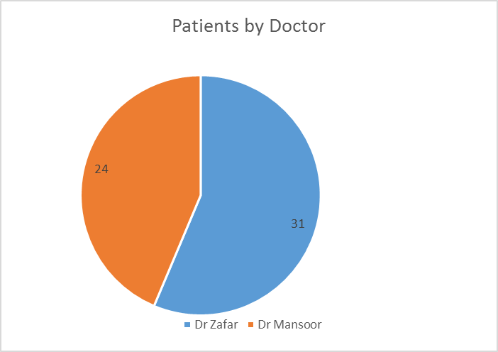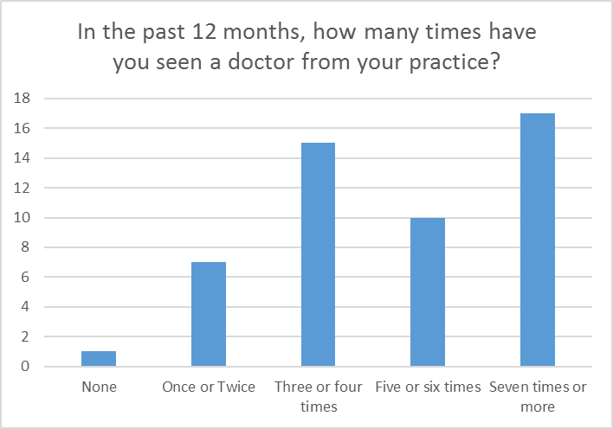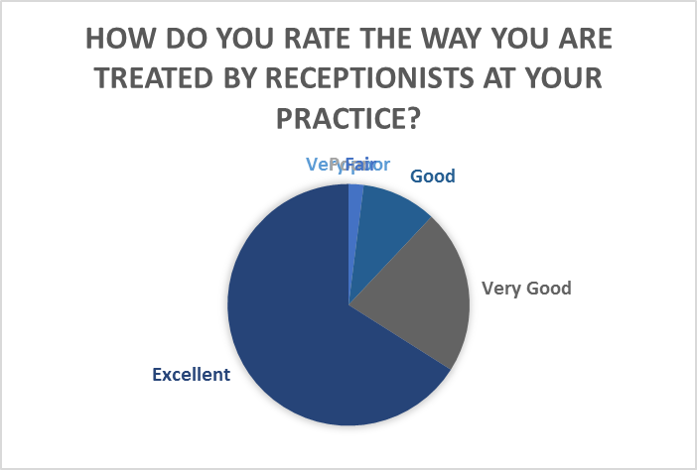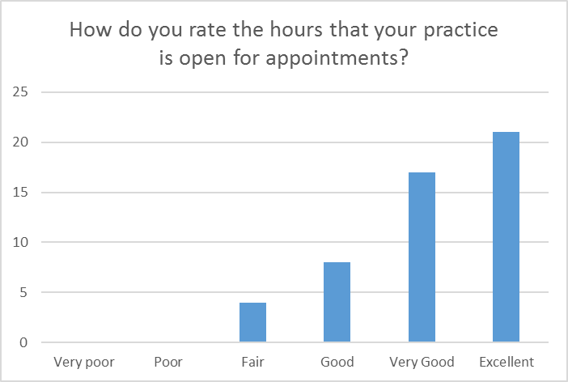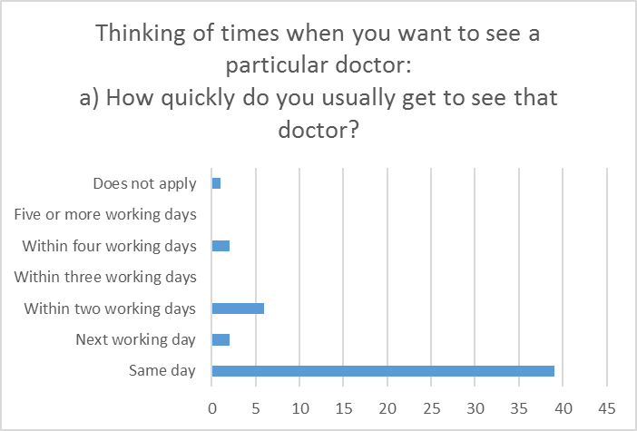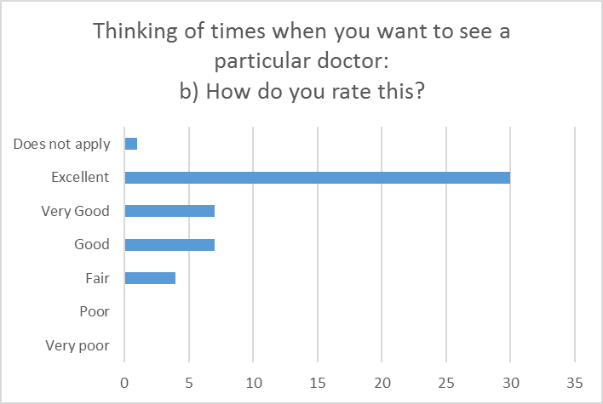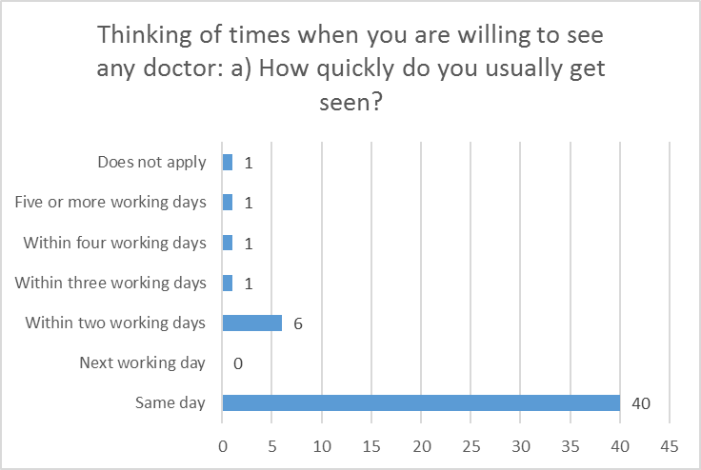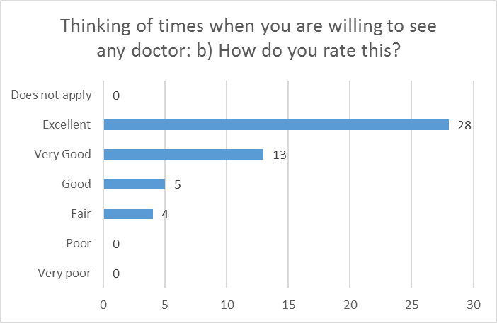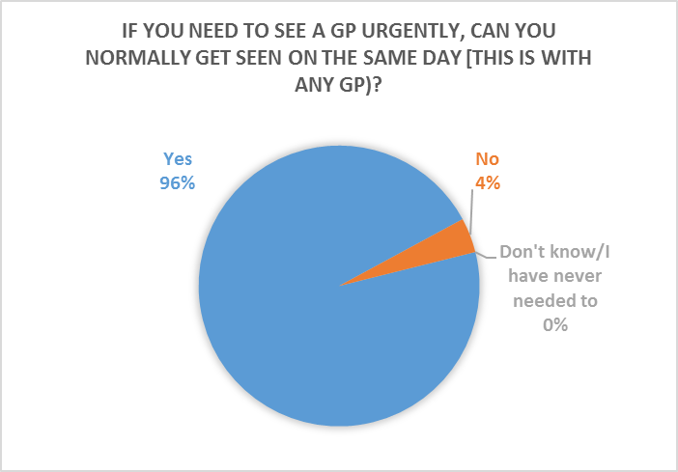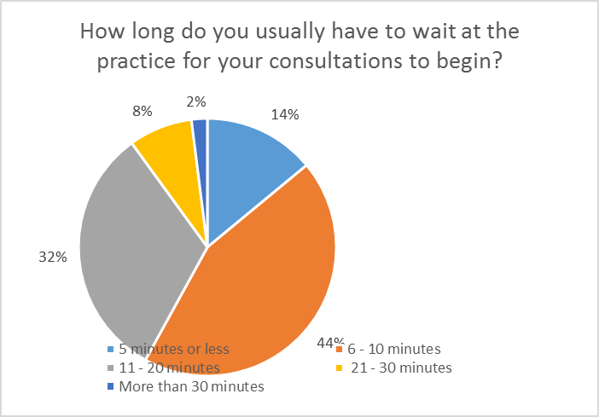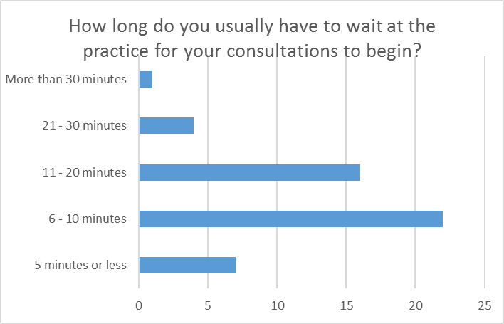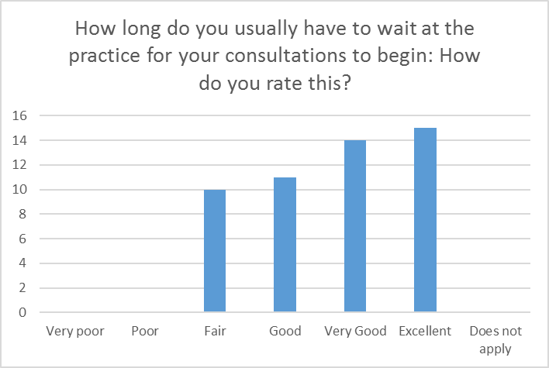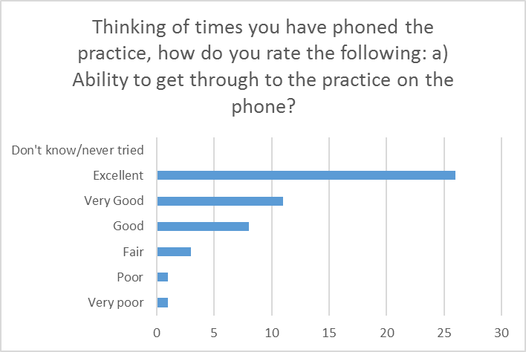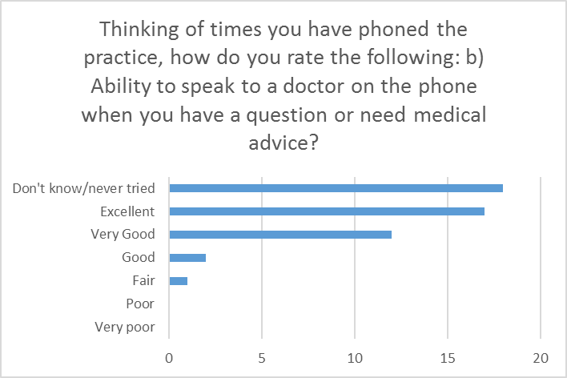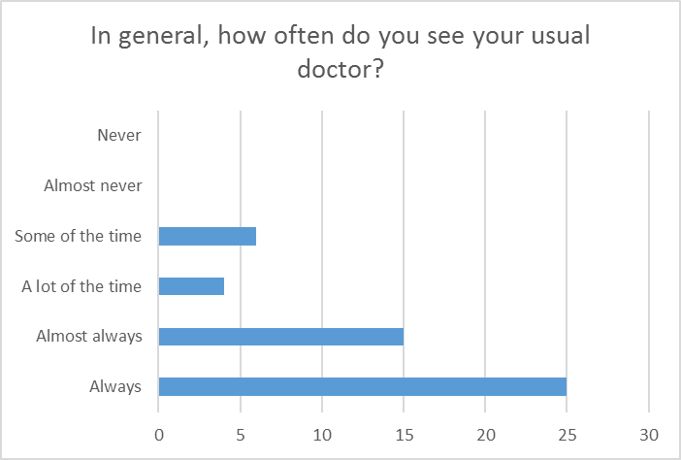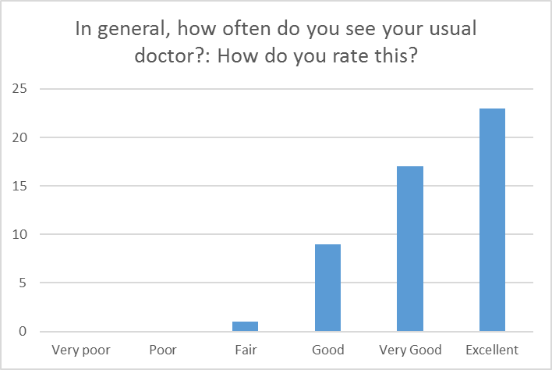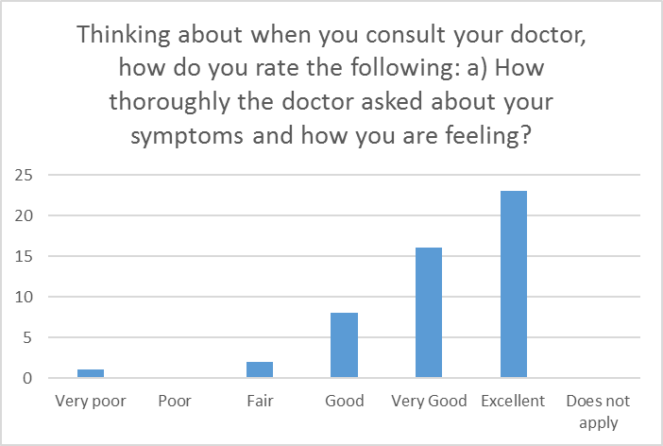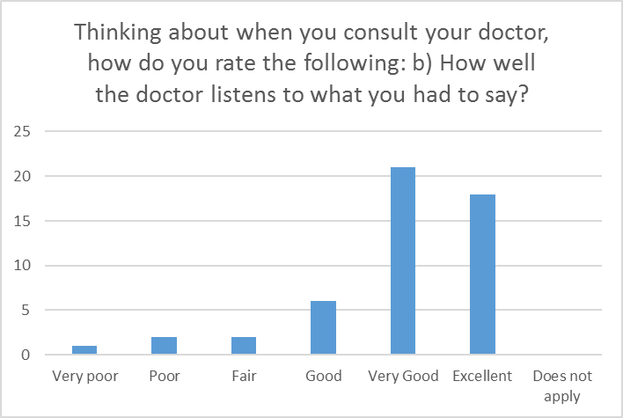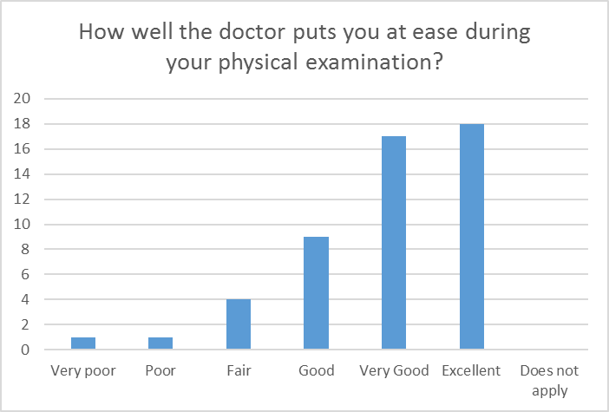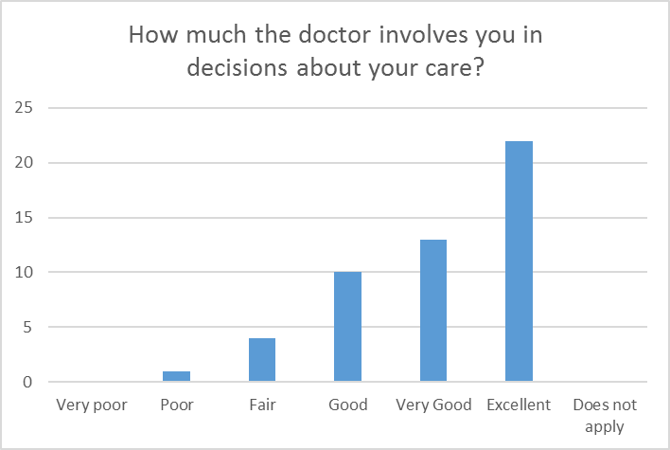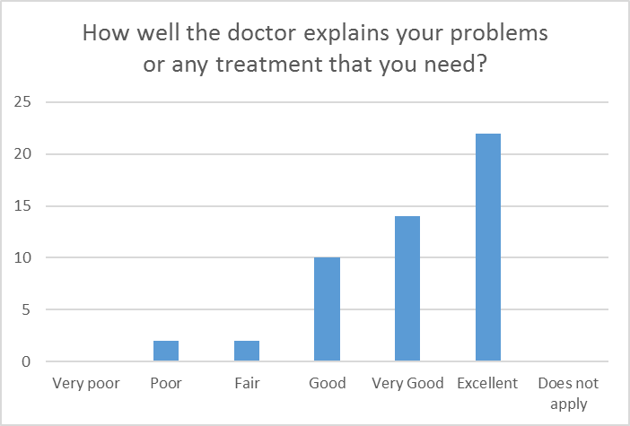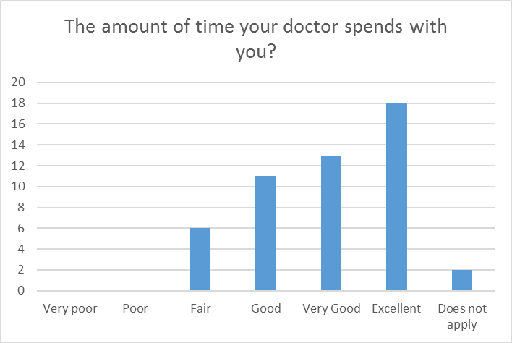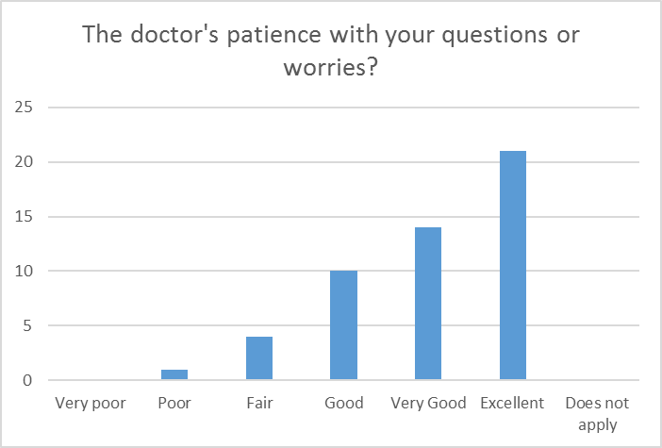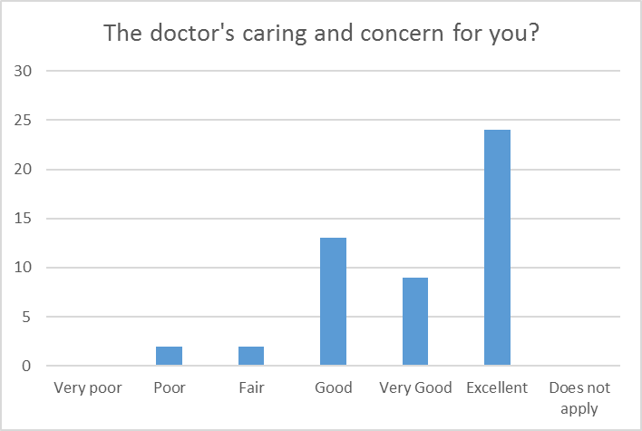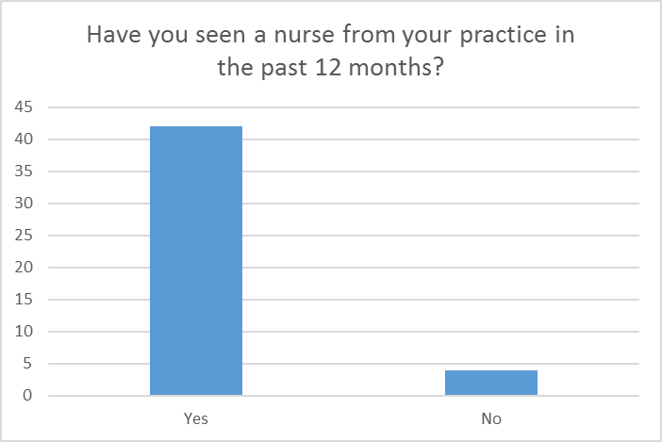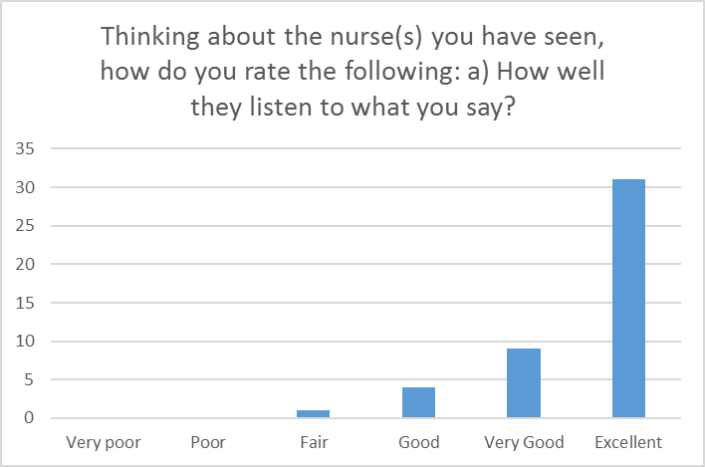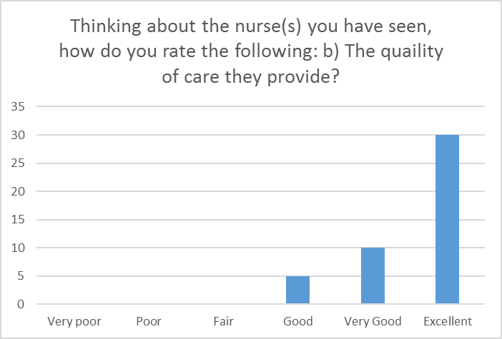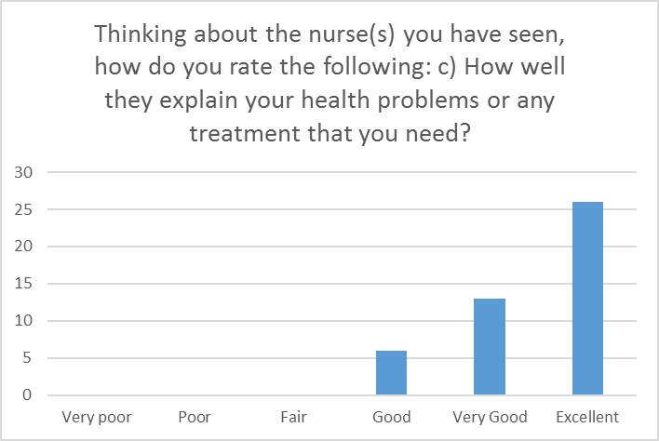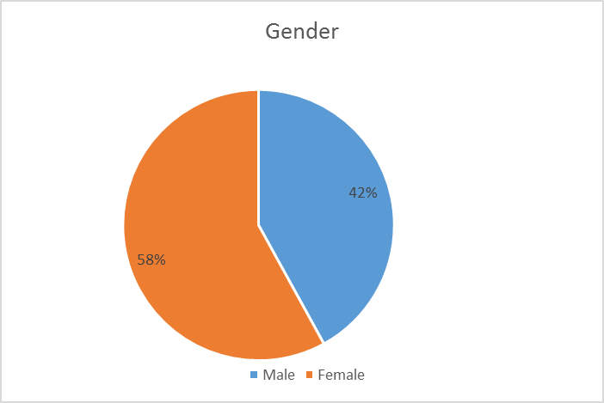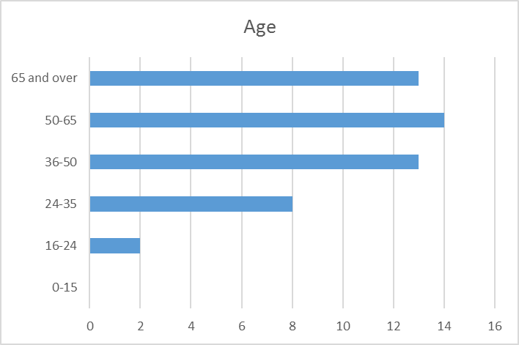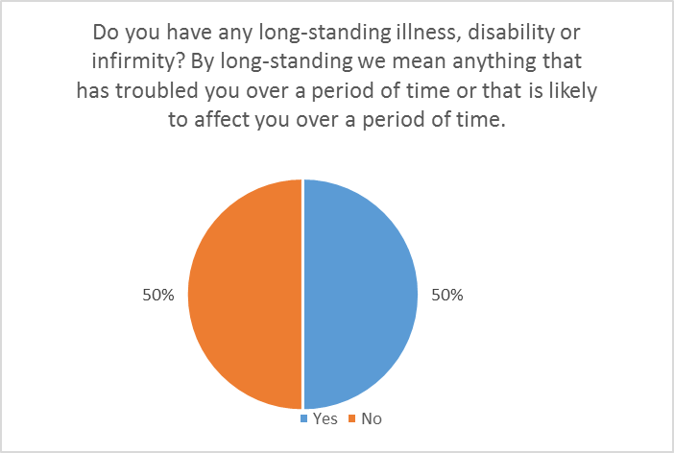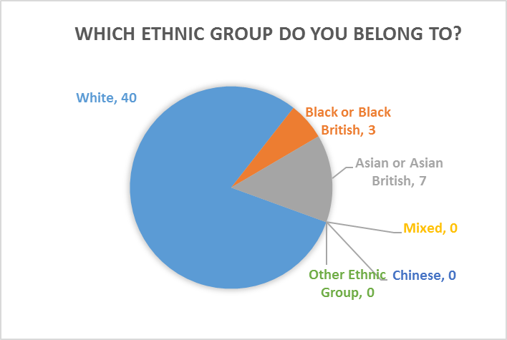
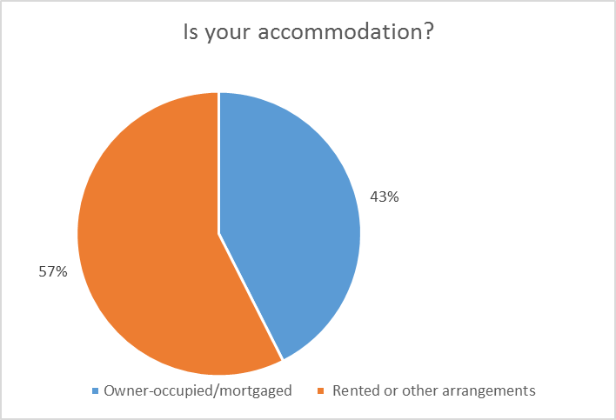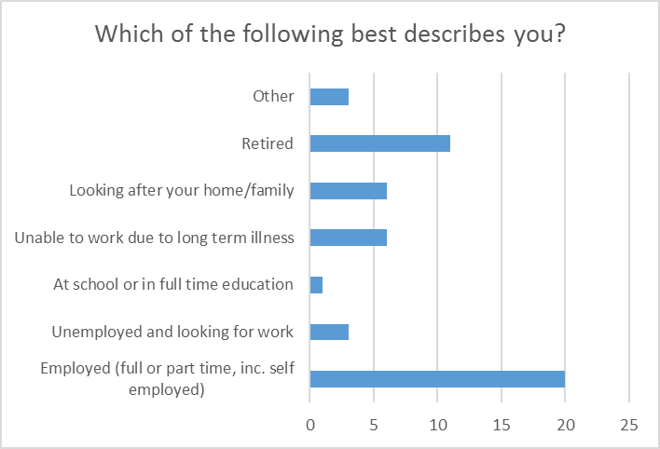

Action Plan
This year’s survey results were reported as over-whelmingly good. However, there are some points that the practice feels that they can improve on.
It was noted:
That the majority of voters said that they have never tried to speak to a doctor on the telephone when they have a question or require medical advice.
Following a practice discussion with clinical and managerical staff, the practice feels that they need to promote this service more so that patients are aware of it. Has decided to offer more telephone appointments on a daily basis to allow patients a telephone consultation. This will free up face to face GP appointmentsand allow for extra consultaion time for patients with extended problems and emergencies and will also help with reducing the demand for appointments, especially for patients to discuss their recent blood test results/ medical problems which can be easily discussed via telephone consultation.
We intend to offer 4 telephone appointments at the begining of each GP's surgery on mornings and afternoons. In turn, we will need to advise our Receptionists to promote telephone consultations to patients and display a notice in the waiting room area as well as on the practice website. We’ll monitor the progress of this by performing a survey on the usage of these extra telephone appointments to ensure that these are being utilised and that patients are receiving the best possible care.
However, before we implent this procedure, we will gain feedback from our Patient Participation Group shortly.
Once implemented for six months, we will audit the useage the results and these will be published on our website and displayed in our waiting room area and will be further discussed with the Patient Participation Group.

Another Point noted was: the waiting times for consultations to begin. It was noted that a typical waiting time for patients to wait for the Doctor’s consultation to begin was 6 – 10 min and 11 – 20 mins.
Often appointments can be delayed if an emergency occurs or a patient needs hospital admission during a consultation or a patient has extensive medical problems. After discussion in a practice meeting the following points were agreed to improve on patient waiting time:

- To allow for more consultation time , thus allowing more time for patient’s with extensive and complicated medical problems
- Allowing more time for new patients to thoroughly discuss their medical history.
- Allow more catch-up time (free appts in between) to allow GP to catch up if a patient appointment is taking longer than expected.
Once again, this will be audited and discussed further in the Practice and the PPG.

